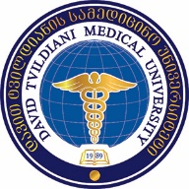
SPps daviT tvildianis samedicino universiteti

danarTi 1
damtkicebulia:
Sps ,,daviT tvildianis samedicino universiteti”-s
2017 wlis 10 martis
reqtoris #12 brZanebis Tanaxmad.

Sps daviTYtvildianis samedicino universitetis
reqtors

gancxadeba

saxeli

gvari

sakonkurso Tanamdeboba  (miuTiTeT erT-erTi) | - sruli profesori  - asocirebuli profesori  - asistent-profesori
departamenti da/an mimarTuleba

ganmcxadeblis xelmowera ----------------------------------------------

TariRi “-------“ ---------------------------------------- 2017 w.

